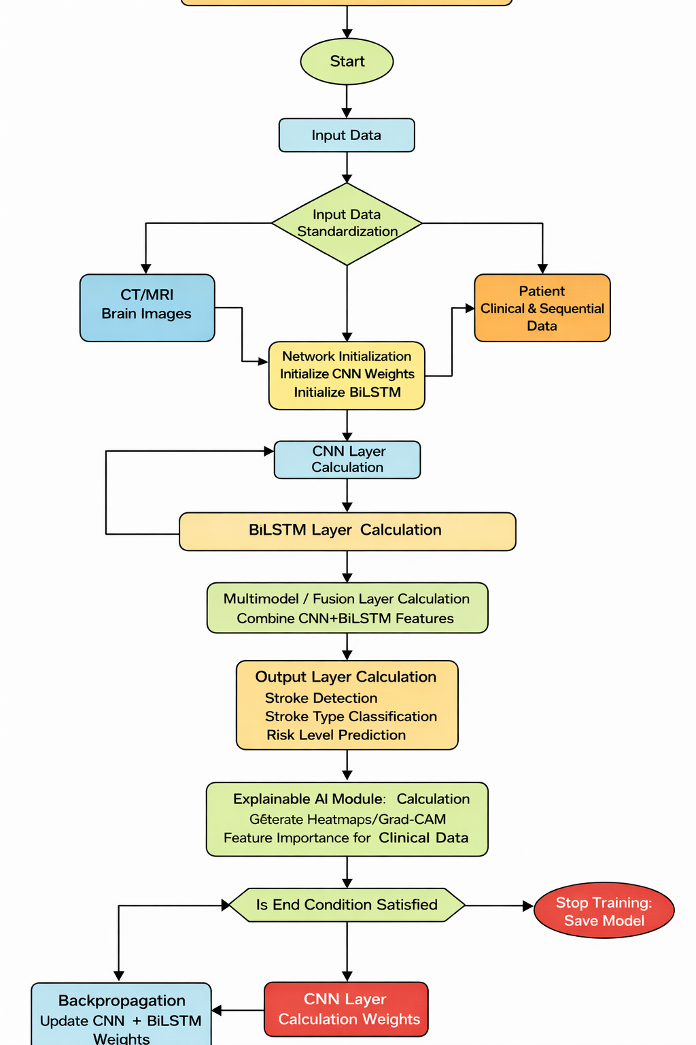
BRAINLENS – A MULTIMODEL ARTIFICIAL INTELLIGENCE SYSTEM FOR STROKE DETECTION AND RISK PREDICTION

Process Diagram
The above diagram shows the overall functional workflow of the proposed BrainLens system, which aims to help doctors identify stroke and predict the risk of future stroke occurrences using artificial intelligence.
The workflow starts with the Start block, which represents the launching of the BrainLens application by a medical professional, such as a doctor or a technician. After launching the system, the user then moves to the Input Data phase. In this phase, the user uploads the CT/MRI images of the brain and also enters the patient’s clinical and health-related data into the system.
After the data has been entered, the system then moves to the Input Data Standardisation phase. In this phase, the application is now ready to analyse the data. The brain images are resized, normalised, and preprocessed, while the clinical data is validated, scaled, and formatted in the correct manner for the learning models.
The system then moves to the Network Initialisation phase. In this phase, the deep learning models are initialised by setting up the CNN and BiLSTM networks with the correct parameters and weights.
After initialisation, the system then moves to the CNN Layer Calculation phase. In this phase, the CNN analyses the brain images and extracts key visual features related to stroke and abnormalities in the brain.
Concurrently, the system executes the BiLSTM Layer Calculation. During this phase, the BiLSTM model evaluates the patient’s clinical and sequential information to learn risk patterns over time.
The results from both the CNN model and the BiLSTM model are then subjected to the Multimodal Fusion Layer. During this phase, the image features and clinical features are merged into a unified representation for final decision-making.
After the fusion process, the system arrives at the Output Layer Calculation phase. During this phase, the system executes three major operations:
• Making predictions regarding the patient’s risk level as low, medium, or high.
Subsequently, the system enters the Explainable AI Module phase. During this phase, the system creates visual heatmaps of brain images and marks critical clinical factors that contributed to the prediction, allowing doctors to interpret and verify the prediction results.
After this phase, the system checks the End Condition of the learning process. If the model attains the desired accuracy, the system saves the trained model and advances to the End block.
If the accuracy is inadequate, the system executes Backpropagation, where the CNN and BiLSTM model weights are adjusted, and the process is repeated until the model learns efficiently.
Finally, the process advances to the End block, signifying the completion of one entire prediction and training cycle. The user can continue utilising the system for further patient analysis.

